

Next-Gen cCommerce
Retail & Distribution Solution

Maximise revenue, achieve targets and
deliver exceptional customer experiences
with Connect Retail Distribution platform - built with airlines for airlines, airline retailing with Offers and Orders.

We’d like this section to come second instead of last. And make this the “Why leading airlines choose us ”
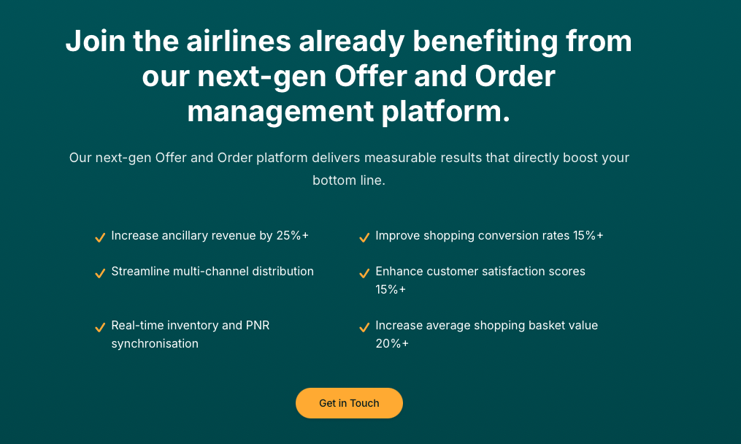

Tangible benefits of choosing Retailaer.
Our next-gen Offer and Order platform delivers measurable results. that directly boost your bottom line.

- 3-5%+ conversion rates
- 20%+ increased average order value
- 60% customer retention rate
- 25%+ ancillary revenue up-lift
- 15%+ enhanced customer satisfaction score
- 30% or less shopping cart abandonment

“Customer quote”

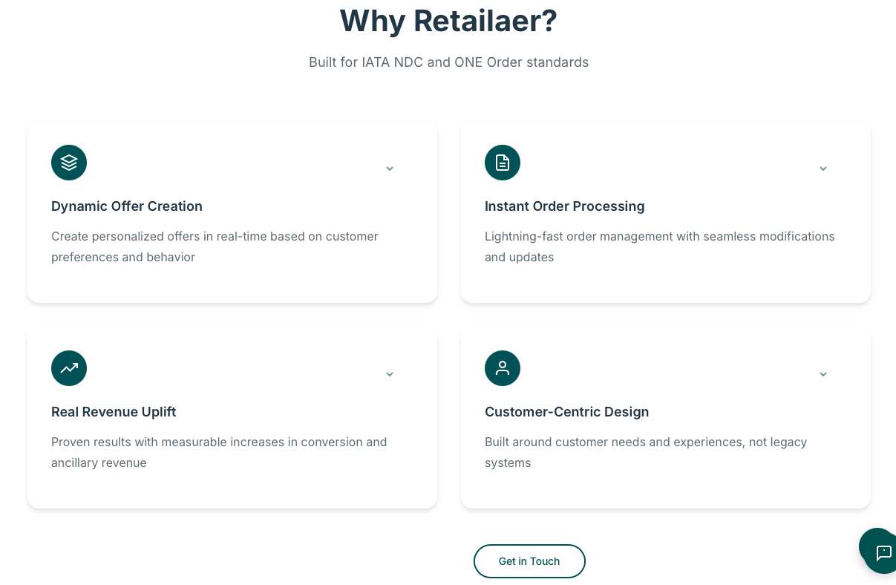

- Streamlined multi-channel offer distribution and order management
- Optimised shopping and checkout experiences
- Sub-second response times and channel optimisation
- Dynamic shopping basket with automated pricing rules
- Innovative marketplace with unlimited product possibilities
- Zero-down time with auto-scaling and load distribution

- Title: How it works
- Underline: Built on key retail driving principles
- Centralise the GiT button and make diamond gold

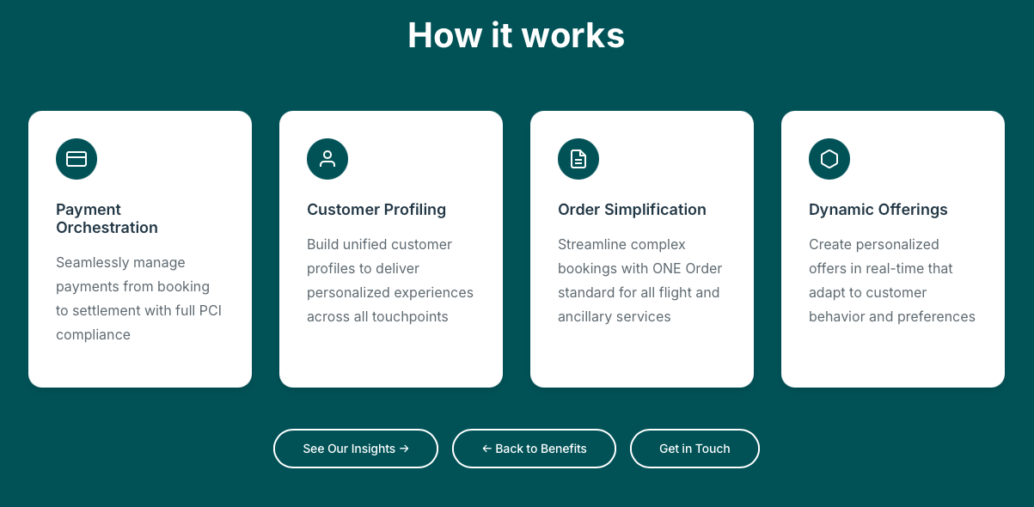

Title: Key Retail Fundamentals

- Frictionless Payments: Seamless and PCI compliant settlement with local and global payment options to secure conversion rates.
- Unified Customer View: 360-degree view of each customer across all touchpoints to enable personalisation.
- Order Optimisation: Instant and simplified order processing for all products and services inclusive of refund and cancel.
- Dynamic Offers: Create relevant offers in real-time that adapt to customer behaviour, preferences and context.

Remove “See our insights” and “Back to benefits”
Unify GiT button to diamond gold



Next-gen airline retailing with Offers and Orders and Marketplace - built with airlines for airlines.

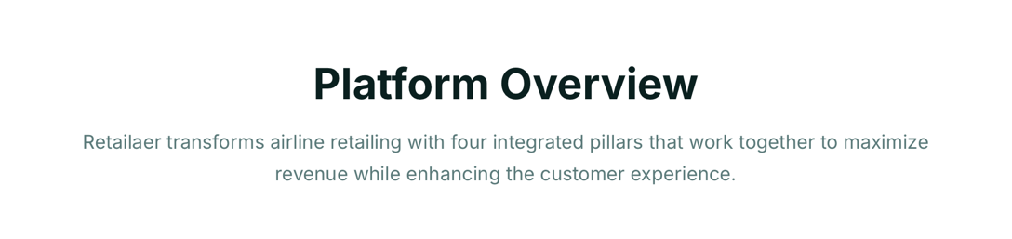
Connect Retail Distribution platform is built on four pillars.

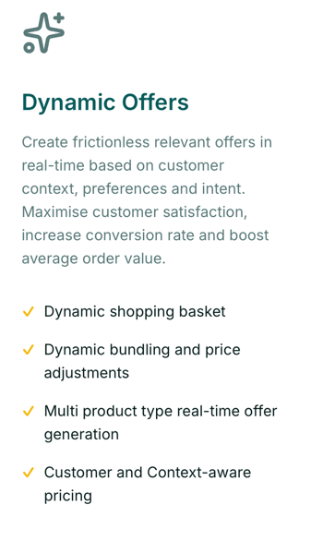
Create frictionless relevant offers in real-time based on customer context, preferences and intent. Maximise customer satisfaction, increase conversion rate and boost average order value.

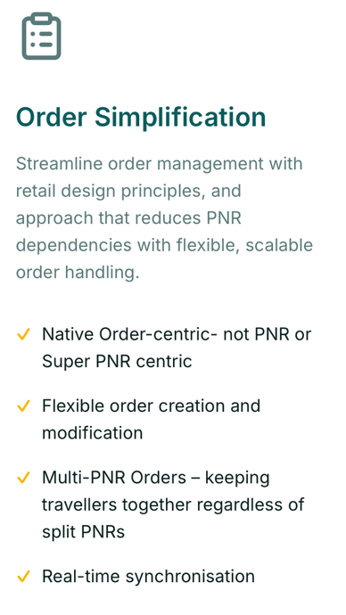Order Optimisation Simplification
Streamlined order management with retail principles, an approach that reduces PNR dependencies with flexible, scalable order management.

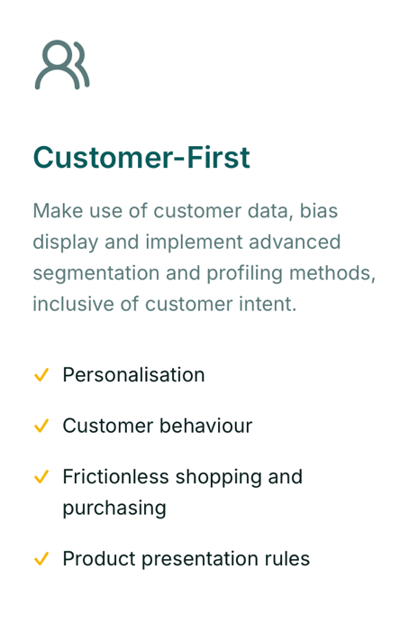

Unified Customer View Customer-First
Make use of customer data, bias display and implement advanced segmentation and profiling methods, inclusive of customer intent.

- Place boxes 2 by 2 in web browser view

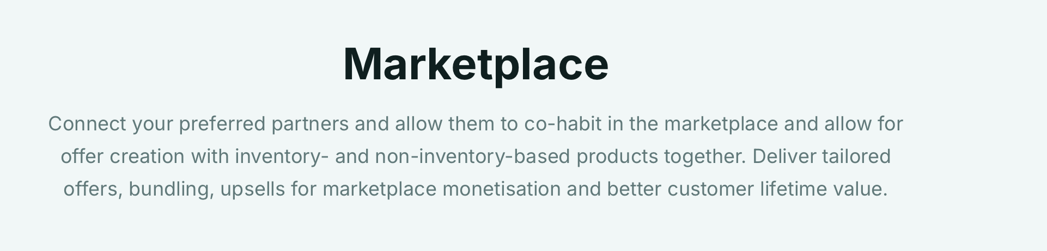

Connect your preferred partners and allow them to co-habit in the marketplace and allow for offer creation with inventory- and non-inventory-based products.

- Place boxes 2 by 2 in web browser view

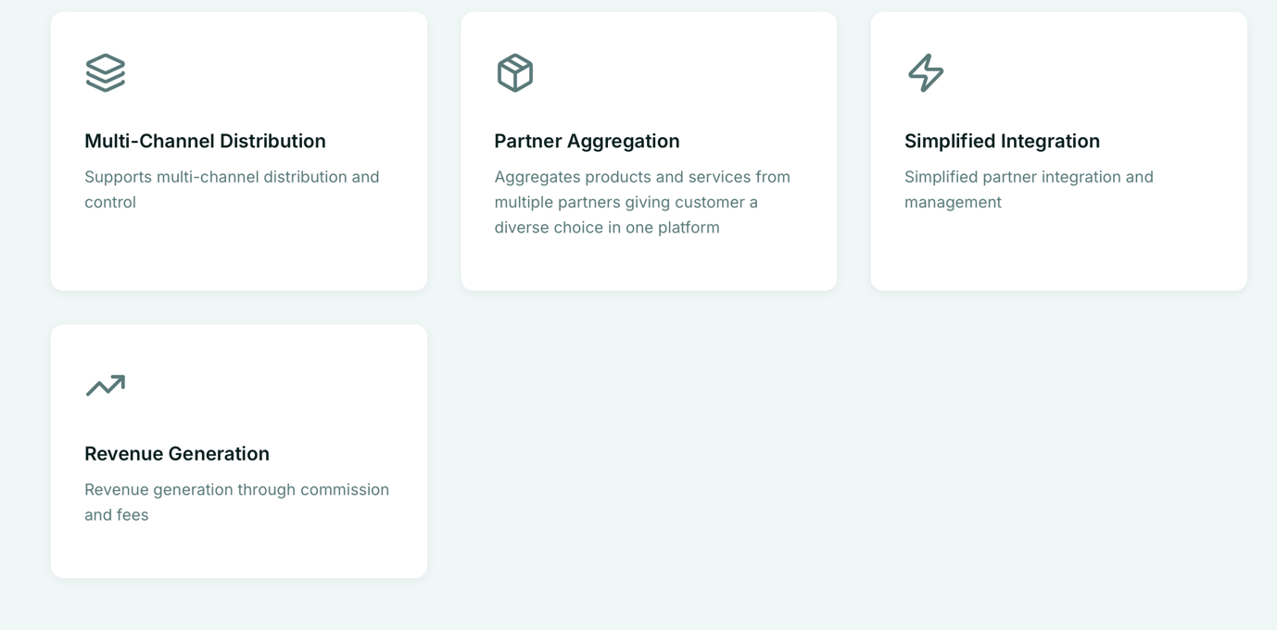

Multi-Channel Distribution
Multi-channel content distribution and pricing differentiation.
- Change icon to more fitting multi-channel

Partner Aggregation
Seamlessly integrate and aggregate products and services from multiple partners giving customers choice.

Simplified Integration (remove box)
Simplified partner integration and management

Revenue Generation Uplift
Generate revenue through commission and fees.
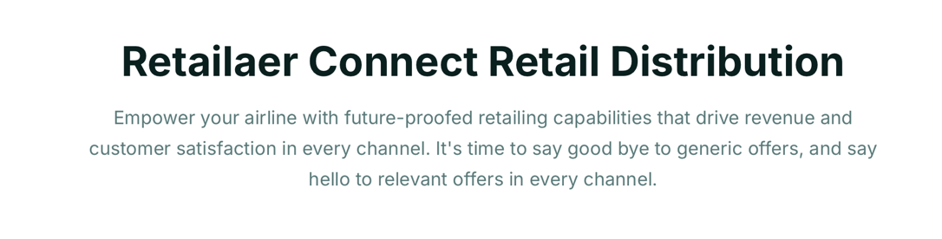
Retailaer Connect Retail Distribution
Empower your airline with retailing capabilities that drive revenue and customer satisfaction. It's time to say goodbye to generic offers, and say hello to relevant offers in every channel.

For Consumers Travellers

Sell flights and ancillary offers, incorporating content from your partners to create a customer-centric experience.

For Corporates
Present offers designed for small to medium sized businesses with the capability of an incentive program, a one stop shop for orders and account management.

For Agencies
A central hub, including order servicing, upselling and cross-selling including renumeration.

For Call centre
Let your call center be an integral part of your sales strategy, equipped with tons of capabilities, your agents don't need to know PSS functions.

For Mobile
Available for customers on the move, get deals and offers, place and manage orders and preferences on-the-go.

For Self-servicing
Lets customers manage their orders, and offer them deals based on the current order and previous purchase history.

For Holidays
Give your customers a dynamically packaged experience at the time of shopping and placing order.

NDC For Aggregators
Distribute optimise offers and order with IATA industry-standard compliant NDC API.

For Airline Staff
Implements the same look and feel for your own staff as for your customers and benefit from understanding the customer experience.

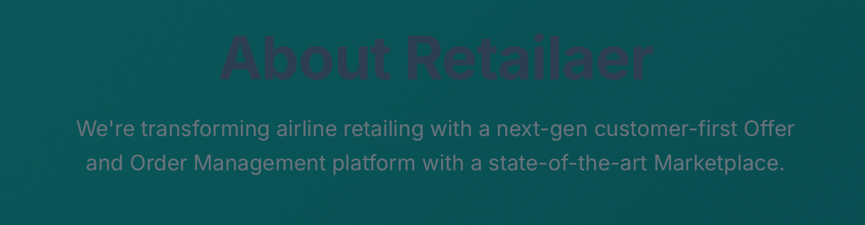
Brighten the text
We're transforming airline retailing with a next-gen customer-first Offer and Order Management platform with a state-of-the-art Marketplace.
A team lead by a former airline executive, building airline retailing tech with airlines for airlines, defining the next-gen eCommerce solutions with Offers and Orders.

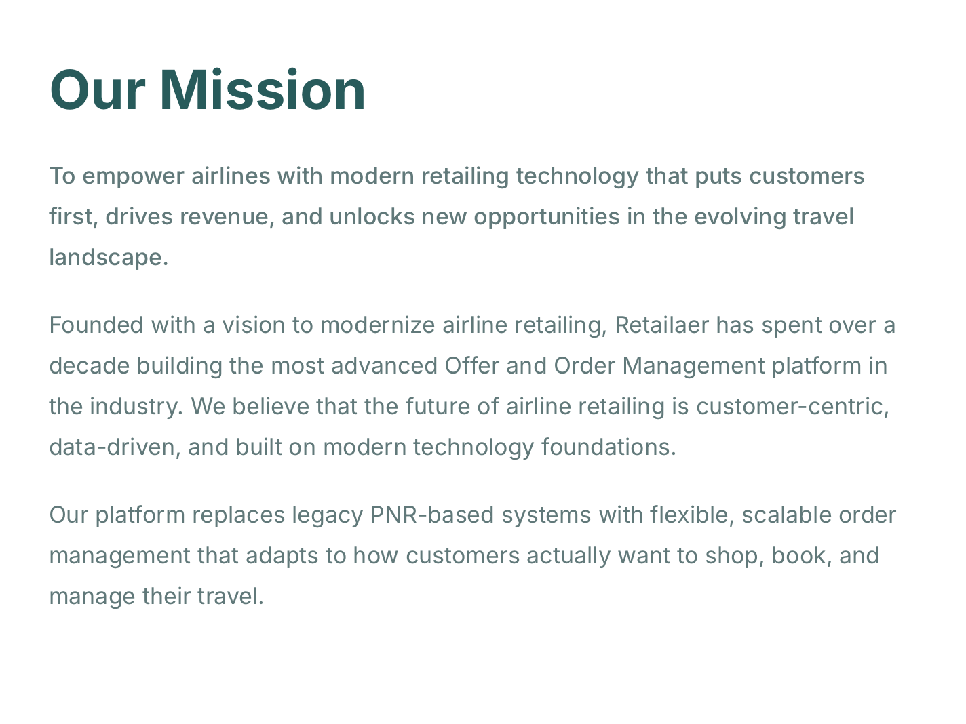

Our Mission
To gives airlines a modern system to reduce PNR-dependency with flexible order management that matches how customers shop, book, and change travel — today and in the era of agentic AI.​

What we do
Over a decade, we've built on third-gen eCommerce for airlines, an Offer and Order Management platform, that handles payments, customer data, dynamic offers and order servicing without legacy limits. Airlines use it to sell bundles, ancillaries, and partner products across channels while tracking everything in one order record.​

Why it works
This setup cuts distribution costs, enables frictionless payments, and lets airlines personalise offers based on customer data — increasing revenue from better conversion and loyalty. Retailaer Connect Retail Distribution platform allows airlines to remain on their PSS and classical documents while ensuring business processes remains intact.

In web browser, place 2-by-2
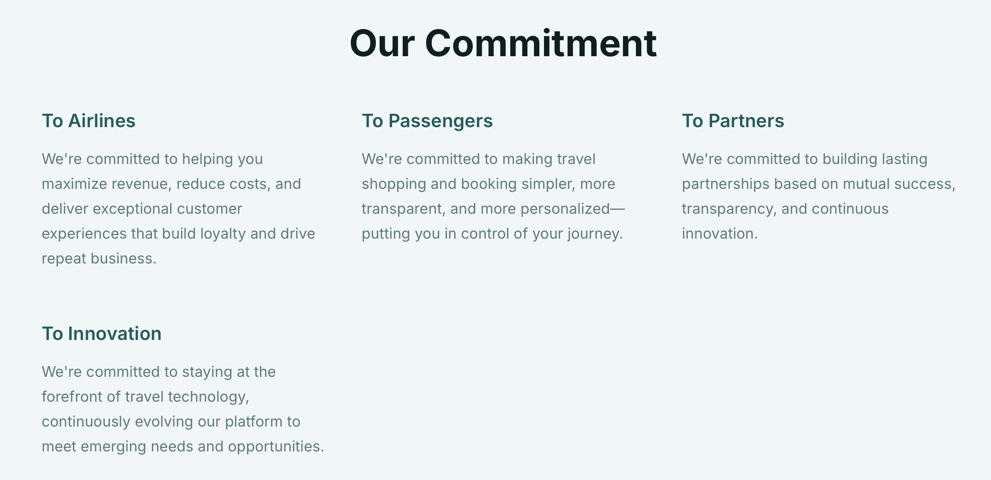

Brighten text
- Remove Email Us
